08/04/2015
DATA MANAGEMENT SYSTEM

2 DMS PROJECT PHASE – I SPECIFICATIONS
2.1 Graphical User Interface

Enabling functionalities for DMS
- Re-naming the DMS database tables and columns
- Export data page’s project info div shall show from start time to end time records of corresponding project from the ‘data_core_ measurements’ table, and change in time format whilst save .csv file
- Database ‘data_core_ measurements’ table shall accommodate all different types such as 1.VLIFE (mk1), 2. VLIM (mk1), 3. VLIFE (mk2) Ty-4
- Create new “create-project” page
- Standard CSV file name for upload data into database

- DMS Database Tables and columns name

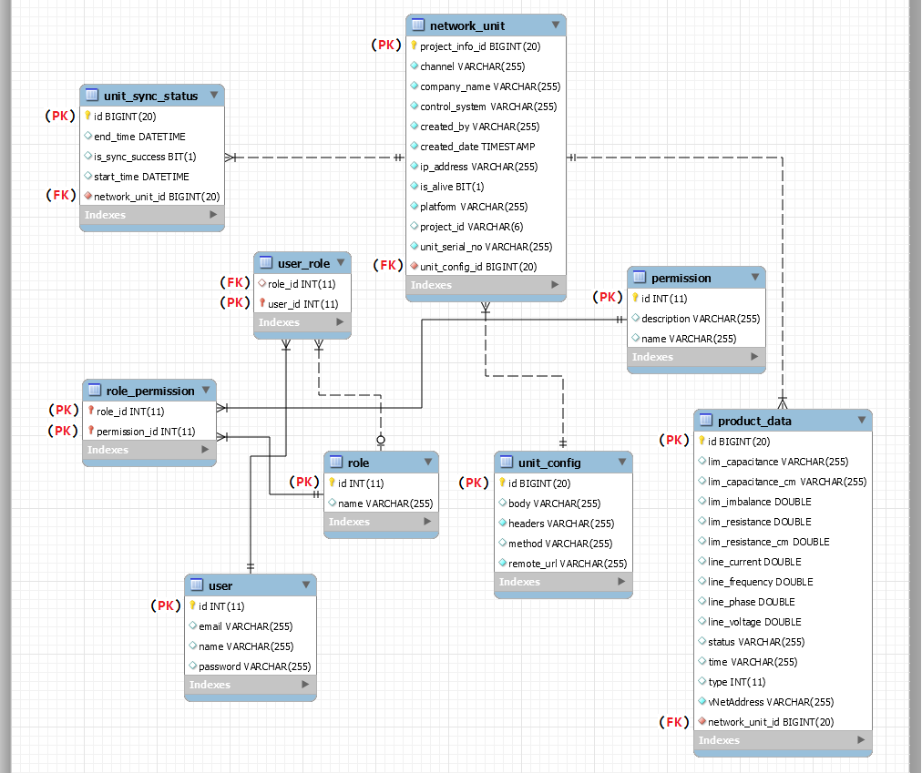
Figure 1: Present database structure

- Refer “Database-Table-Column-Names - 08_04_2015.doc” for detailed table names and column names;

2. Export unit data
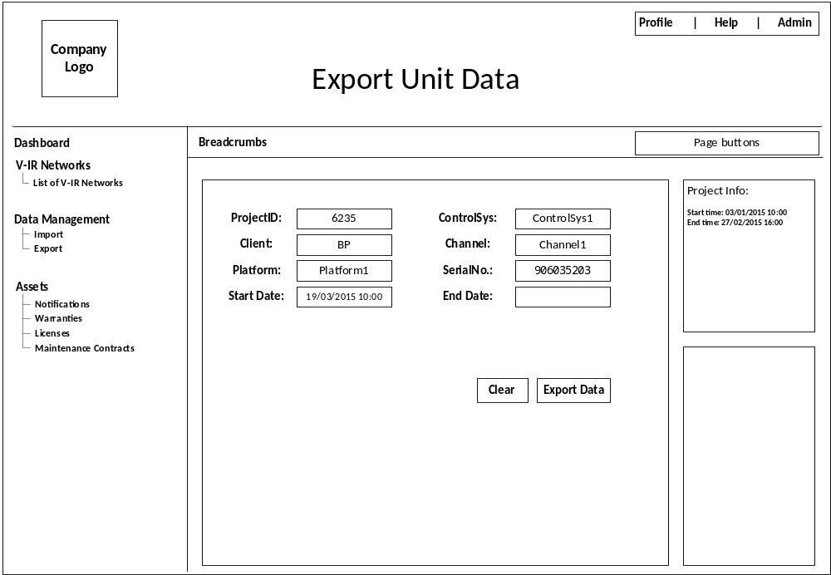
Figure 2: Export data page
Export data page;
- After selecting ProjectID, ControlSys, Client, Channel, corresponding available data’s start-date and end-date shall be shown in the “Project Info:” div so that when user make selection accordingly using DateTime picker.
- When download;
  - Downloaded .csv shall have new timestamp format <dd/mm/yyyy HH:MM:SS> (Instead of <yyyy-mm-ddTHH:MM:SS>) at time column

3. Create project
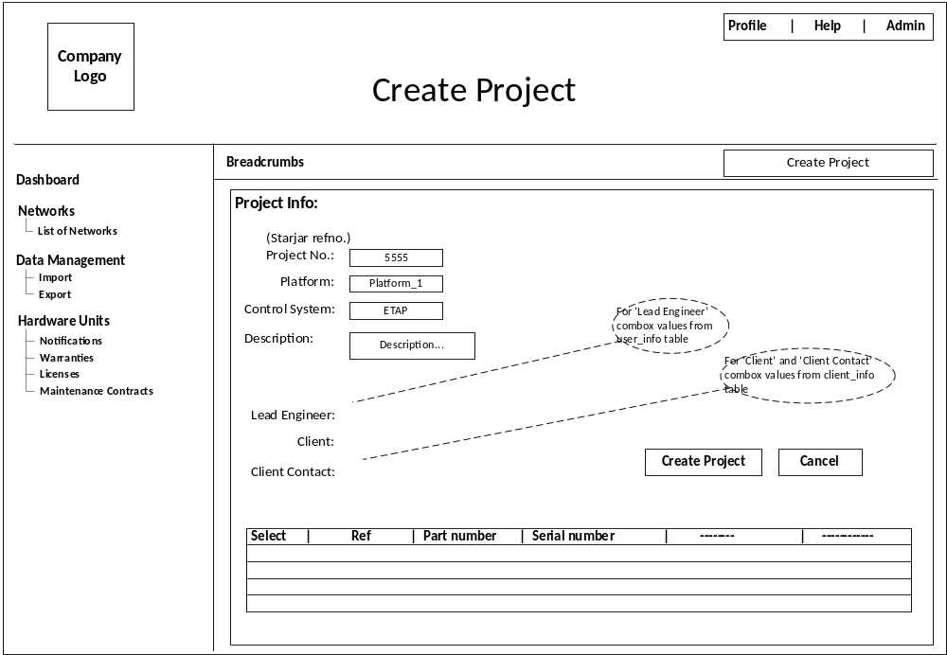
Figure 3: Create project page.
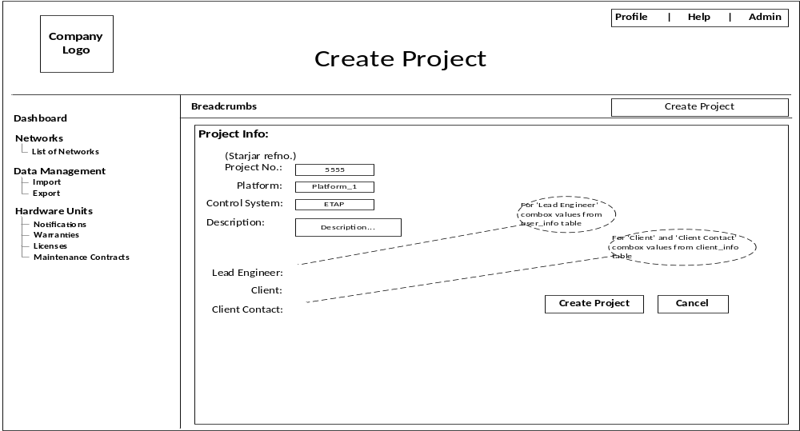
Figure 4: Create_project page with normal table on it.
Create project page;
- Instead of pop-up shall have separate page.
- First four textboxes 1. Project No. (Starjar Ref no.), 2. Platform, 3. Control System, 4. Description shall read the values from the user.
- Next three fields 1. Lead Engineer, 2. Client, 3. Client Contact shall have combobox and the values read from ‘user_info’ table and ‘client_info’ table respectively.
- Normal HTML Table should populate few values from the “network_unit” (present)/ “project_info” (proposed) tables, such as 1. part_no, 2. serial_no…
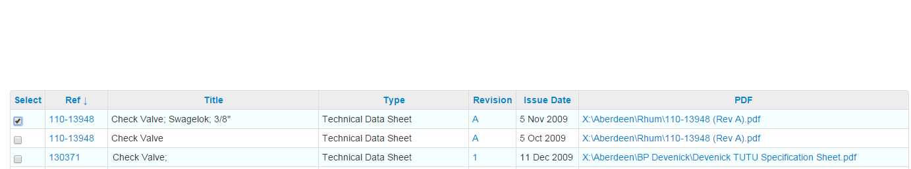
Select column shall have check box to select the particular row.
Note: Only displaying the values on the create_project page for now, creating a new project in the database will be done once the create_page is finalised.

4. Detailed graphing
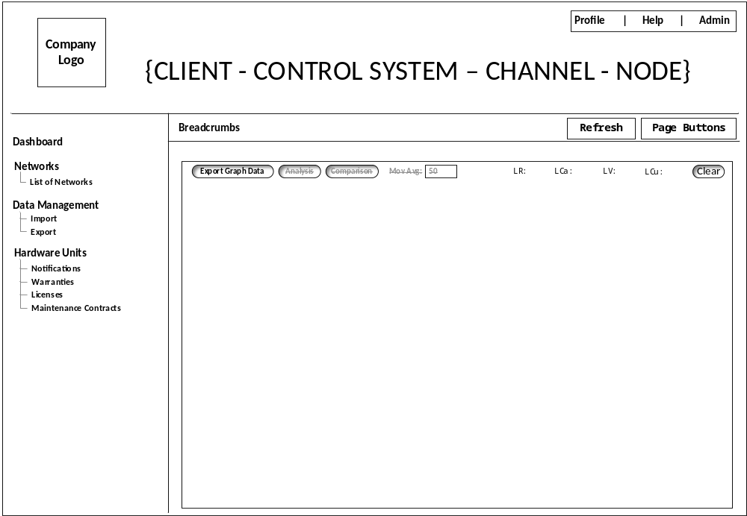
Figure 5: Graph page
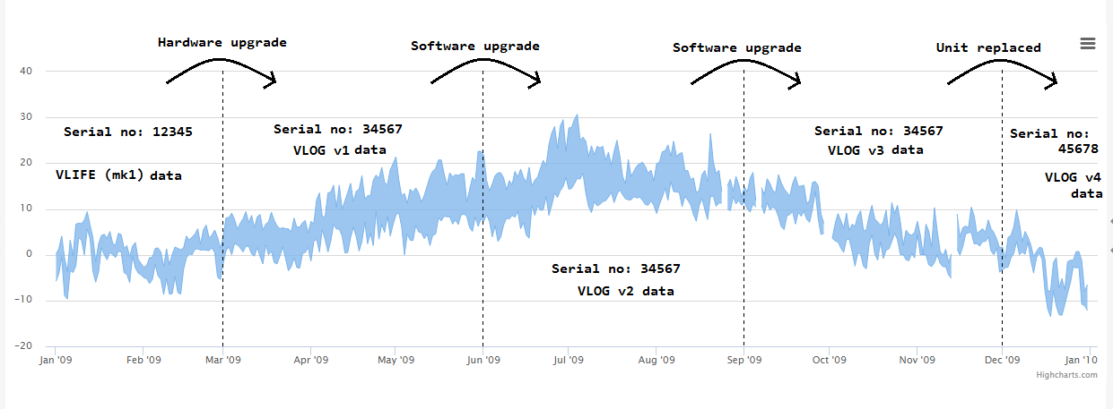
Figure 6: Graph view
Graph page;
- Remove the right side divs and bottom div to use full space for the graph.
- The graph should show the complete history data log of one particular project.
Typical scenario shown in figure 6:
  - From jan-09 to mar-09 The hardware unit is installed with vlife-(mk1) data log readings and assigned under the project ID 6617 with serial no. 12345
  - From mar-09 to jun-09 hardware upgrade with vlim-(mk1) data log readings and assigned under the same project ID 6617 with serial no. 34567
  - From jun-09 to sep-09 software upgrade with vlim-(mk2) data log readings and assigned under the same project ID 6617 with serial no. 34567
  - From sep-09 to dec-09 software upgrade with vlim-(mk3) data log readings and assigned under the same project ID 6617 with serial no. 34567
  - From dec-09 to ---- unit is replaced with vlim-(mk4) data log readings and assigned under the same project ID 6617 with serial no. 45678

5. Upload data
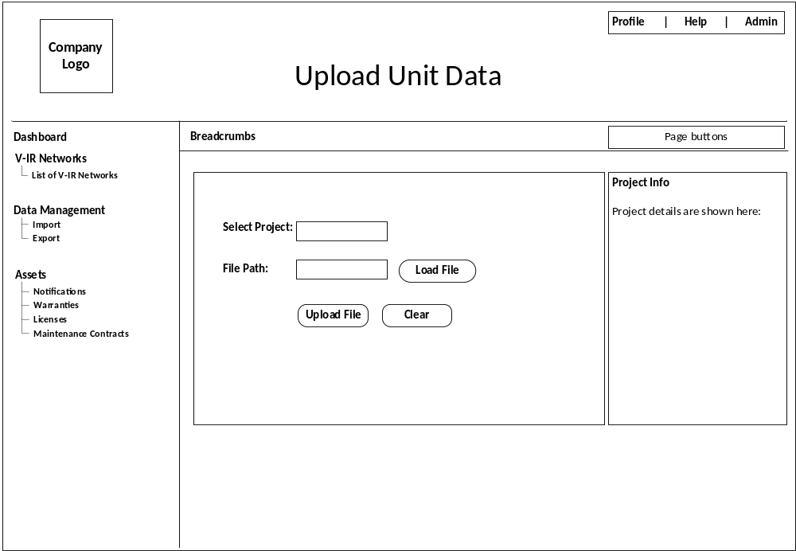
Figure 7: Upload data page

Upload page;
- The values shown in the tooltip, shall also display on the ‘project info’ div
- When upload VLIFE (mk1) file, should check;
  - Is valid .csv file
  - File format ex: “VIPER-855703555-Birch_ChB-Brae_Alpha-2015-03-20T15-53-50.csv”
<VIPER>-<serial number>-<platform>-<control system>-<yyyy-mm-ddTHH:MM:SS>
  - The file name should be in above format is for VLIFE (mk1) type, if not, upload rejects
  - Check only <VIPER>, <serial number>, and <yyyy-mm-ddTHH:MM:SS>, to make sure its belongs to VLIFE (mk1) data log
  - Check <serial number> is matches with ‘unit_serial_no’ column at product_info table, if valid then uploads.
  - When uploads VLIFE (mk1) type
  Time ->
  Type ->
  Status ->
  Mode ->
  Reading no. ->
  IR ->
  LIMVoltage ->
  LIMCurrent ->
  Temperature ->
  LineVoltage1 ->
  LineVoltage2 ->
  LineCurrent ->
  LimResistance ->
  column_n ->
  column_o ->
  column_p ->
  Column_q ->
  Col:02 at data_core_measuremets table
  Col:04 at data_core_measuremets table
  Col:05 at data_core_measuremets table
  Col:02 at data_vlife_mkone table
  Col:03 at data_vlife_mkone table
  Col:07 at data_core_measuremets table
  Col:04 at data_vlife_mkone table
  Col:05 at data_vlife_mkone table
  Col:06 at data_vlife_mkone table
  Col:11 at data_core_measuremets table
  Col:07 at data_vlife_mkone table
  Col:12 at data_core_measuremets table
  Col:08 at data_vlife_mkone table
  Not used
  Not used
  Not used
  Not used

- After upload successful or decline a small relevant message pop-up window is shown to the user.
- When upload VLIM (mk1) file, should check;
  - Is valid .csv file
  - File format ex: “vlim-datalog_906035206_2015-02-01.csv”
<vlim-datalog>_<serial number>_<yyyy-mm-dd>
  - The file name should be in above format is for vlim mk1 type, if not, upload rejects
  - Check <vlim-datalog>, <serial number>, <yyyy-mm-dd>, to make sure its belongs to VLIM (mk1) data log
  - Check <serial number> is matches with ‘unit_serial_no’ column at product_info table, if valid then uploads.

  - When uploads VLIM (mk1)
  Time ->
  VNetAddress ->
  Type ->
  Status ->
  LimImbalance ->
  LimResistance ->
  LimCapacitance ->
  LimResistanceCm ->
  LimCapacitanceCm ->
  LineVoltage ->
  LineCurrent ->
  LineFrequency ->
  LinePhase ->
  Col:02 at data_core_measuremets table
  Col:03 at data_core_measuremets table
  Col:04 at data_core_measuremets table
  Col:05 at data_core_measuremets table
  Col:06 at data_core_measuremets table
  Col:07 at data_core_measuremets table
  Col:08 at data_core_measuremets table
  Col:09 at data_core_measuremets table
  Col:10 at data_core_measuremets table
  Col:11 at data_core_measuremets table
  Col:12 at data_core_measuremets table
  Col:13 at data_core_measuremets table
  Col:14 at data_core_measuremets table

  - After upload successful or decline a small message pop-up window is shown to the user.
- When upload VLIFE (mk2) Ty-4 file, should check;
  - Is valid .csv file
  - File format ex: “vlim-datalog_906035206_2015-03-01.csv”
<vlim-datalog>_<serial number>_<yyyy-mm-dd>
  - The file name should be in above format is for vlife mk2 Ty-4, if not, upload rejects
  - Check <vlim-datalog>, <serial number>, <yyyy-mm-dd>, to make sure its belongs to VLIFE (mk2) Ty-4 data log
  - Check <serial number> is matches with ‘unit_serial_no’ column at product_info table, if valid then uploads.
  - When uploads vlim mk1 Ty-4
  Time ->
  VNetAddress ->
  Type ->
  Status ->
  LimResistance ->
  LineVoltage ->
  VlifeMode ->
  VlifeParam ->
  VlifeVoltage ->
  Col:02 at data_core_measuremets table
  Col:03 at data_core_measuremets table
  Col:04 at data_core_measuremets table
  Col:05 at data_core_measuremets table
  Col:07 at data_core_measuremets table
  Col:11 at data_core_measuremets table
  Col:17 at data_core_measuremets table
  Col:18 at data_core_measuremets table
  Col:19 at data_core_measuremets table

  - After upload successful or decline a small message pop-up window is shown to the user.
Sample files for testing:
- “VIPER-855703555-Birch_ChB-Brae_Alpha-2015-03-20T15-53-50.csv” is for VLIFE (mk1)
- “vlim-datalog_906035206_2015-02-01.csv” is for vlim (mk1)
- “vlim-datalog_906035206_2015-03-01.csv” is for vlife (mk2) Ty-4

